S3 File Operations via CLI (Upload, List,Delete)

1. Objective
This document explains how to perform the following tasks in Amazon S3 using AWS CLI:
- Create a test file locally
- Upload the file to an S3 bucket
- List objects in the bucket
- Delete specific files or the entire bucket
These steps can be used for daily tasks, testing permissions, or validating S3 CLI functionality.

2. Prerequisites
Before running AWS CLI commands:
- AWS CLI must be installed
- IAM user must be configured using aws configure
- IAM user must have S3 permissions (s3:PutObject, s3:ListBucket, s3:DeleteObject)
- If bucket uses SSE-KMS encryption, user must have related KMS permissions
So , here I successfully configure the AWS configure via CLI using the IAM user’s credentials:

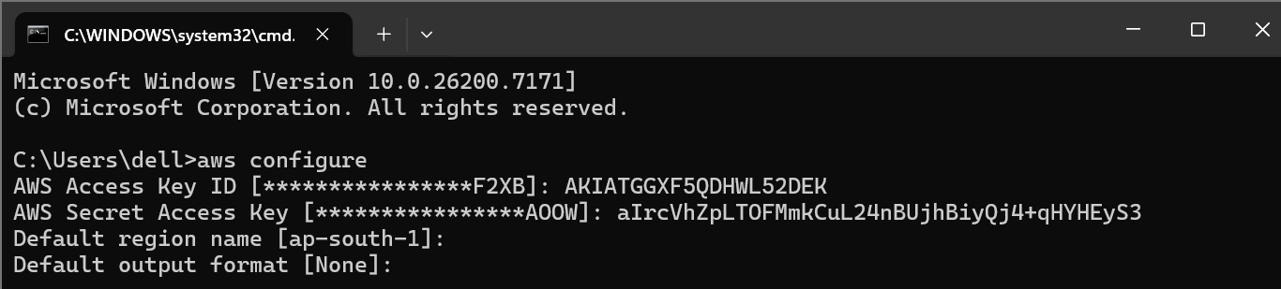
I was trying to list the bucket. So I ran command :
# aws s3 ls
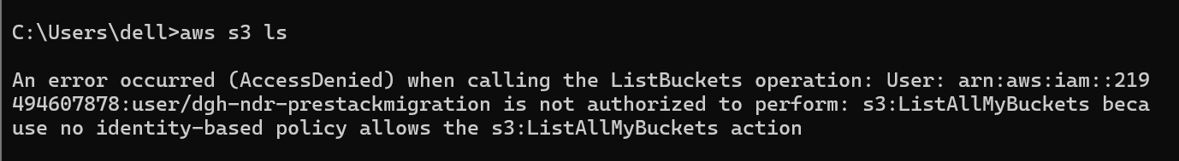
But it resulted a error
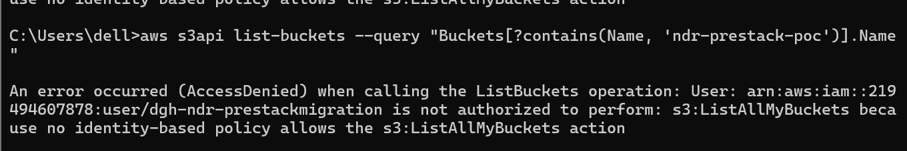
AccessDenied (KMS key error)

Occurs when the bucket uses SSE-KMS and you lack permission.
Fix: Ask admin to allow kms:GenerateDataKey and related KMS permissions.

First I uploaded a textfile into my S3 bucket.

Text file Uploaded
Windows CMD / PowerShell me run:
echo "This is a test file" > testfile.txt

Verify file:
dir

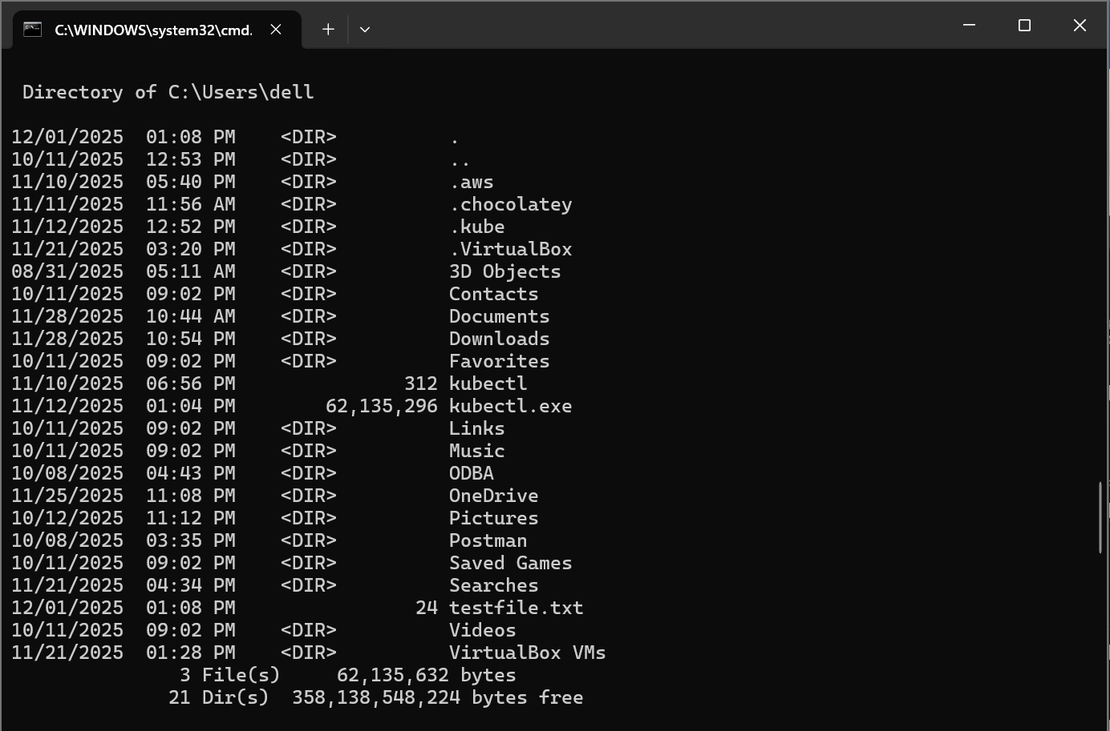
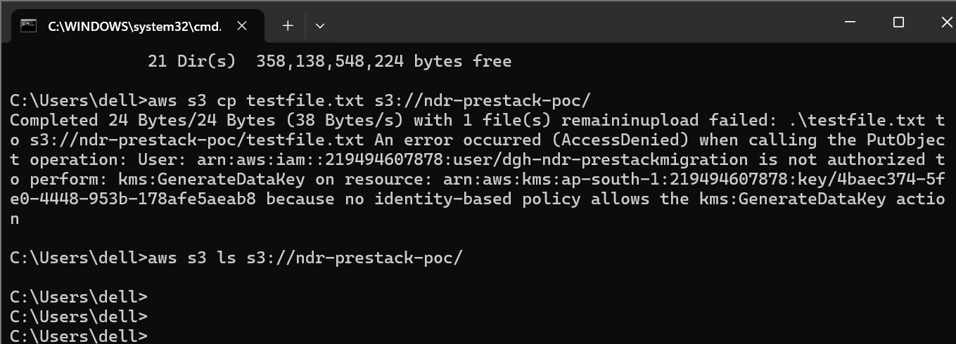
Here, bucket KMS-encrypted
⚠ Your IAM user does NOT have permission for:
kms:GenerateDataKey
My IAM user does not have permissions for the KMS key used by the bucket, so S3 PutObject is failing. I need kms:GenerateDataKey permission on key ARN: arn:aws:kms:ap-south-1:219494607878:key/4baec374-5fe0-4448-953b-178afe5aeab8
to fix this
Add to IAM User → Permissions → Add inline policy:
{
"Version": "2012-10-17",
"Statement": [
{
"Effect": "Allow",
"Action": [
"kms:GenerateDataKey",
"kms:Encrypt",
"kms:Decrypt"
],
"Resource": "arn:aws:kms:ap-south-1:219494607878:key/4baec374-5fe0-4448-953b-178afe5aeab8"
}
]
}

Text file uploaded in S3 Bucket.
Syntax:
aws s3 cp testfile.txt s3://<bucket-name>/

Example:
aws s3 cp testfile.txt s3://ndr-prestack-poc/

Output:
upload: ./testfile.txt to s3://ndr-prestack-poc/testfile.txt
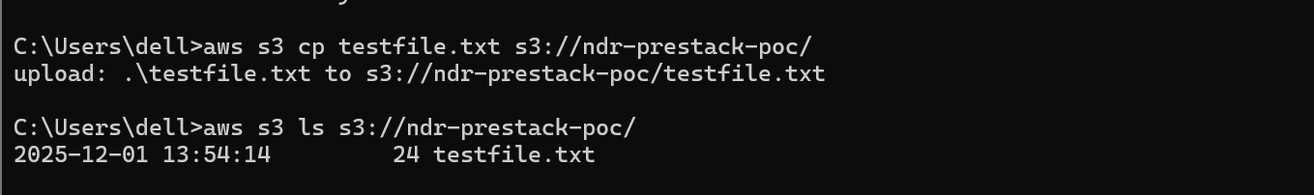
List with full metadata: # aws s3api list-objects --bucket ndr-prestack-poc
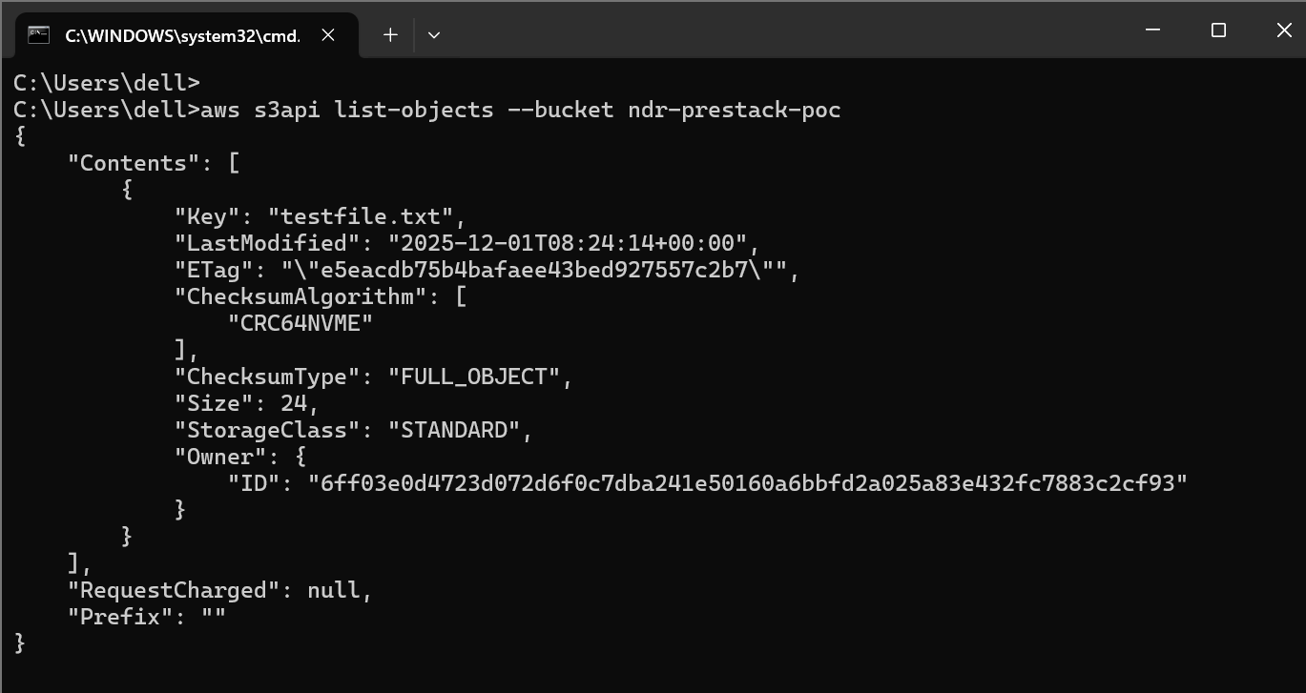

Delete Files from the S3 Bucket

Delete a specific file
aws s3 rm s3://ndr-prestack-poc/testfile.txt
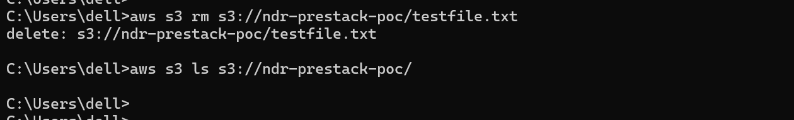
Common Errors & Fixes
1. AccessDenied (KMS key error)
Occurs when the bucket uses SSE-KMS and you lack permission.
Fix: Ask admin to allow kms:GenerateDataKey and related KMS permissions.
2. AccessDenied for s3:ListBucket
User lacks S3 read permissions.
Fix: Add S3 permissions to IAM user.

